[](http://www.google.be/imgres?imgurl=http://www.groupdebrandt.com/beelden/pralines.jpg&imgrefurl=http://www.groupdebrandt.com/boters/melkpoeder.html&usg=__r5q-Ip9PUoqrzjopFeHjOUM9qUM=&h=150&w=170&sz=19&hl=nl&start=40&zoom=1&um=1&itbs=1&tbnid=3HPSz9uSQHeUWM:&tbnh=87&tbnw=99&prev=/images%3Fq%3Dpralines%26start%3D20%26um%3D1%26hl%3Dnl%26sa%3DN%26ndsp%3D20%26tbs%3Disch:1&ei=3nBrTf3cNMbr4gai6OnhCQ) [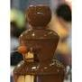](http://www.google.be/imgres?imgurl=http://shop.publirent.be/148-148-home/chocoladefontein-30---150-personen.jpg&imgrefurl=http://shop.publirent.be/13-opdienmateriaal%3Fn%3D20%26p%3D3%26id_category%3D13&usg=__I6OgjnlkpZuivM53Dq-9qHlFXog=&h=129&w=129&sz=6&hl=nl&start=98&zoom=1&um=1&itbs=1&tbnid=1JiBJjTEXT49RM:&tbnh=91&tbnw=91&prev=/images%3Fq%3Dchocoladefontein%26start%3D80%26um%3D1%26hl%3Dnl%26sa%3DN%26ndsp%3D20%26tbs%3Disch:1&ei=m3FrTa3oDc6B4Qbvo5HiCQ)[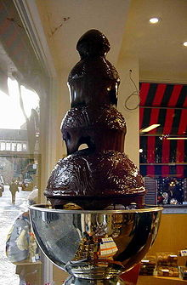](http://nl.wikipedia.org/wiki/Bestand:Chocolate_fountain.jpg) [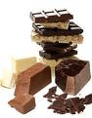](http://www.google.be/imgres?imgurl=http://www.mamsatwork.nl/home/wp-content/uploads/2011/02/chocolade.jpg&imgrefurl=http://www.mamsatwork.nl/home/2011/02/02/de-beleving-die-mamameets-heet/&usg=___ZgqN6tnCKEedd18edwm1vujzsU=&h=364&w=282&sz=41&hl=nl&start=216&zoom=1&um=1&itbs=1&tbnid=ux8VuA2C28556M:&tbnh=121&tbnw=94&prev=/images%3Fq%3Dchocoladefontein%26start%3D200%26um%3D1%26hl%3Dnl%26sa%3DN%26ndsp%3D20%26tbs%3Disch:1&ei=p3JrTYHwIZ2d4AbdrMzhCQ) [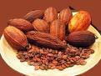](http://www.google.be/imgres?imgurl=http://www.nutrilab.be/images/dbimages/pics/thumb_cacaobonen_01WEB_copy_3.jpg&imgrefurl=http://www.nutrilab.be/content.php%3FhmID%3D23%26smID%3D13&usg=__uEiWoNEW9YWGt8eB8vfj7lmkBrc=&h=269&w=359&sz=86&hl=nl&start=1&zoom=1&um=1&itbs=1&tbnid=f_VORmLSu2HpAM:&tbnh=91&tbnw=121&prev=/images%3Fq%3Dcacaobonen%26um%3D1%26hl%3Dnl%26tbs%3Disch:1&ei=ynJrTcqZL4Oj4Qa8ldHhCQ)